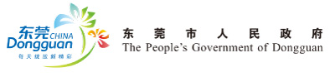
Appendix 1：
Reply Slip
□ I will attend the Promotion Conference on Dongguan’s Investment
Opportunities, 2011 at 15:30 p.m. on October 13th, 2011 (Thursday)
□ I will attend the buffet dinner on October 13th, 2011.
□ I will not attend the Promotion Conference.
( Please indicate your choice by “√”)

Organization |  | website
Address |  | Zip Code
Name |  | Position
Telephone |  | Fax
Mobile |  | E-mail

What would you like to know about the business environment of Dongguan City?
___________________________________________________________________

___________________________________________________________________

Please reply by email before Sep. 26th, 2011.
For inquiries, please contact: China-Italy Chamber of Commerce
Tel: 0086-21-54075181 Fax: 0086-21-54075182 E-mail: infoshanghai@cameraitacina.com

